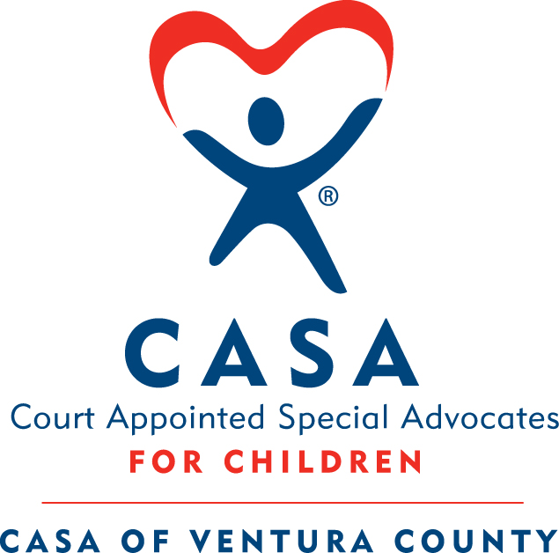
CASA of Ventura County Volunteer Training

The CASA Flex Training consists of 8 in-person 3-hour classes, 5 online classes, and 3 hours of courtroom observation completed over a 6-week cycle. You must finish all training and observation within the 6 weeks, and all background checks must be completed and cleared in order to be sworn in as a CASA.

Spring Flex Training: April 10 – May 15, 6:00 pm – 9:00 pm

Tues., April 10: In-Person - Mandatory Class Introduction
By Mon., April 16: Complete Online Session 1: Getting Started; Introduction to Child Welfare
Tues., April 17: In-Person – The Role of the CASA Volunteer; Introduction to Child Abuse and Neglect
By Mon., April 23: Complete Online Session 2: Strengths and Risks
Tues., April 24: In-Person – Family Strengths; Introducing Yourself as a CASA; Greene Case Study
By Mon., April 30: Complete Online Session 3: Cultural Competence and Disproportionality
Tues., May 1: In-Person – Court Reports, The Amarillo Case
Thurs., May 3: In-Person – Commercially Sexually Exploited Children (CSEC)
By Mon., May 7: Complete Online Session 4: Achieving Permanence
Tues., May 8: In-Person – Child Development; Older Youth; The Brown Case
Thurs., May 10: In-Person –Juvenile Dependency Team Panel Discussion
By Mon., May 14: Complete Online Session 5: Wrapping Up – The Redd Case
Tues., May 15: In-Person – Redd Case Debrief, CASA Panel

Additional Training Expectations

Courtroom Observation: 3 Hours of Courtroom Observation to be completed on a Monday during training. A sign-up sheet will be available at the first In-Person class.
Swearing-In Ceremony: Monday, May 21, 2018 at 12:00 pm
Attend this ceremony to take your volunteer oath of appointment after completing the training. The ceremony is held at the Juvenile Courthouse at 4353 E. Vineyard Ave., Oxnard. Please join us at the office immediately following the swearing-in for a celebratory luncheon. You are welcome to bring one guest.
Continuing Education: You will be required to complete 12 hours of Continuing Education each calendar year that you are an active volunteer. We offer a variety of trainings to help volunteers complete this requirement.

