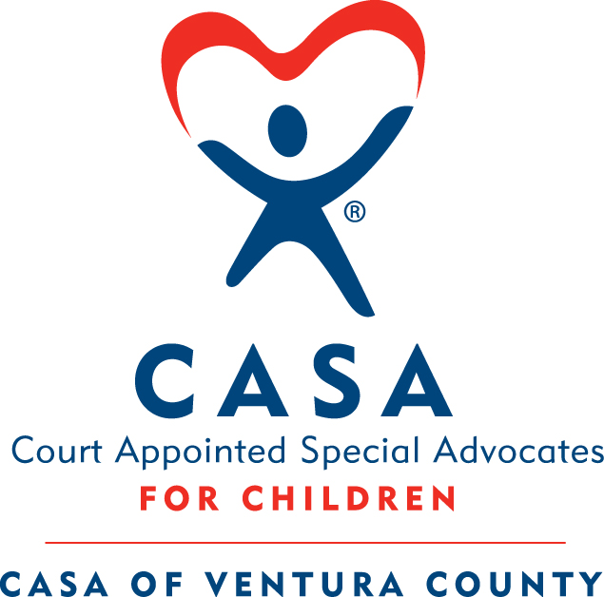
CASA of Ventura County Volunteer Training

The CASA Traditional Training consists of 10 in-person 3.5-hour classes, reading with some online activities prior to each class, and 3 hours of courtroom observation completed over a 5-week cycle. You must finish all training and observation within the 5 weeks, and all background checks must be completed and cleared in order to be sworn in as a CASA.

Fall Traditional Training: October 9 – November 8, Tuesdays and Fridays 9:00 am – 12:30 pm
Thursday, November 8th 6:00 – 8:00 pm

Tuesday, Oct. 9: The CASA Volunteer Role
Friday, Oct 12: The Well-Being of a Child
Tuesday, Oct. 16: Trauma, Resilience and Communication Skills
Friday, Oct. 19: Mental Health, Poverty and Professional Communication
Tuesday, Oct. 23: Substance Abuse and Cultural Competence
Friday, Oct 26: Domestic Violence and Cultural Competence
Tuesday, Oct. 30: Educational Advocacy, Older Youth and LGBTQ Youth
Friday, Nov. 2: Commercially Sexually Exploited (CSEC)
Tuesday, Nov. 6: Wrapping Up
Thursday, Nov. 8: Juvenile Dependency Panel (6-8 pm)

Additional Training Expectations

Courtroom Observation: 3 Hours of Courtroom Observation to be completed on a Tuesday during training. A sign-up sheet will be available at the first In-Person class.
Swearing-In Ceremony: Tuesday, November 13, 2018 at 12:00 pm
Attend this ceremony to take your volunteer oath of appointment after completing the training. The ceremony is held at the Juvenile Courthouse at 4353 E. Vineyard Ave., Oxnard. Please join us at the office immediately following the swearing-in for a celebratory luncheon. You are welcome to bring one guest.
Continuing Education: You will be required to complete 12 hours of Continuing Education each calendar year that you are an active volunteer. We offer a variety of trainings to help volunteers complete this requirement.

